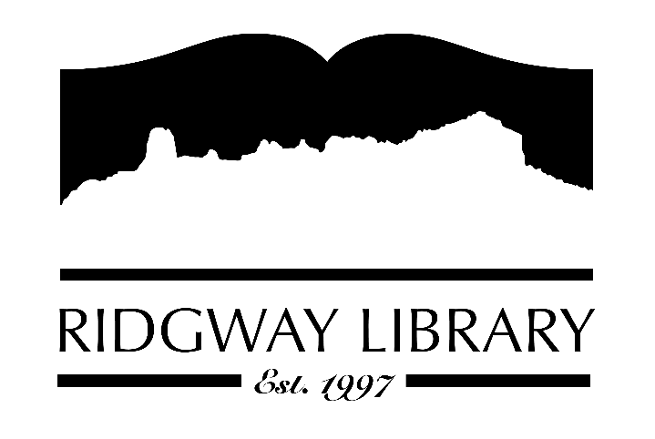

Meeting Minutes
RIDGWAY PUBLIC LIBRARY DISTRICT
BOARD OF TRUSTEES
Regular Meeting
Thursday, December 12, 2024 at 10:30 a.m.

Ridgway Public Library
300 Charles Street

Roll Call: Trustees: Julie Duff, Alison Etheridge, Jared Coburn, Julie Herrmann, Dee Moore, Heather Patterson, Sally Trapp, Library Director: Amy Baer

Approval of Prior Minutes: from November 14, 2024 meeting, Julie Duff made motion to approve, seconded by Alison Etheridge

Next Meeting: Wednesday, January 8, 2025, 1:00 p.m.

Public Comments: Kathy Almont asked Amy to thank the board for again this year returning money to the county.

Friends of the Library Update: Jill Hepp was unable to be present. Amy reported Friends are continuing to raise money.

Highlighted Topic: Adult Bingo will begin January 2nd and run through March 31st

Action and Discussion Items:
- Julie Duff presented final budget for 2025. She reminded everyone that we have 1 year and 3 months of expenses in reserves. Appreciation was expressed to Julie and Amy for all the work done on budget preparation. Sally Trapp made the motion to approve the budget, seconded by Heather Patterson.
- Amy reported Caitlan is attending a workshop and has personally paid for the tuition. It was agreed to reimburse her for the tuition. The Employee Assistance Policy will be reviewed to decide if room and board as well as travel expenses could be paid for employees attending future workshops.
- Annual director’s evaluation review – Sally Trapp thanked everyone for returning the completed evaluation review. Amy received high marks from staff and board members. Amy was asked to leave room so board members could discuss salary and bonus. Motion to increase her salary by 7% was made by Dee Moore, seconded by Alison Etheridge. Suggestion was made to do review before budget preparations and nearer to Amy’s hire date.

Treasurers Report - Julie Duff
- Budget update – covered in above action item #1.

Director’s Report – Amy Baer
- Statistics – patron count down in November but still actively making new patron cards. Circ numbers were up as well as Aspencat ebook and audio usage. PLAR will open mid-January to fill out and submit information to the state.
- Upcoming Programs in 2025 – Second adult bingo will be offered in January and continue for 3 months. Tech Tuesdays will begin in January, 2nd and 4th Tuesdays. A patron has offered his services to lead this class. Amy has a few names of volunteers looking to offer sewing and other crafting skills. Working on details.
- Staff evaluations and reviews will be done beginning of the year.
- Community Outreach – library shared books for giveaways during December Literary Talks at Sherbino. Another Sherbino event next week with Craig Childs will also offer books. Amy will join a committee in January hosted by the Sherbino to help with collaboration of community groups to bring in authors. Collaboration with Ouray County Cares and Ouray County Food Pantry over past month went well. Patrons picked up and returned the sock and angel ornaments. Amy will attend quarterly CTC meeting next week.

Future Agenda Items – Election of officers will be done at January meeting. Also clarification of Employee Assistance Policy needs to be done. Committee to address above concerns about date of Amy’s review will also be decided.

Adjournment – Motion to adjourn, 12:30 pm Dee Moore, seconded by Alison Etheridge.

