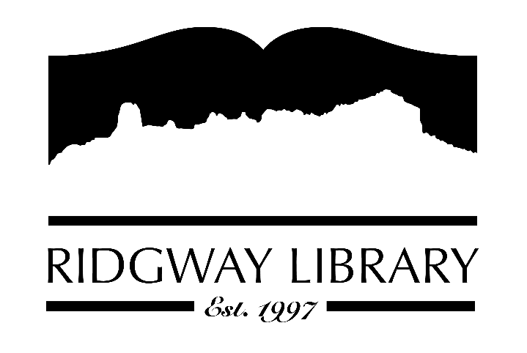

AGENDA
RIDGWAY PUBLIC LIBRARY DISTRICT
BOARD OF TRUSTEES
Regular Meeting
Friday October 13, 2023 at 1:00 p.m.

Ridgway Public Library
300 Charles Street

Zoom option:

https://us06web.zoom.us/j/87433174134

Roll Call: Trustees: Julie Duff, Alison Etheridge, Sandy Hennessy, Julie Herrmann, Jeff Pryor, Sally Trapp, Jenny Williams, Library Director: Amy Baer

Approval of Prior Minutes: from September 8, 2023 meeting

Next Meeting: November 10, 2023 at 1:00 PM

Public Comments:

Friends of the Library Update:

Action and Discussion Items:

- Revisit Code of Conduct with Children policy for discussion and vote to approve revision – Amy.
- Schedule discussion date for director annual review – Sally.

Treasurers Report - Julie Duff
- Discussion for 2024 Budget

Director’s Report - Amy Baer
- Building & Maintenance Update
- Statistics Report
- Streamline
- Volunteers

Future Agenda Items

Adjournment

The Board reserves the right to add or delete items of business and to change the order of business as needed. The Board welcomes public participation in the meetings. If specific accommodations are needed, please contact the Director, Amy Baer, (970)626-5252 or email library@ouraynet.com at least 24 hours in advance of the meeting.

