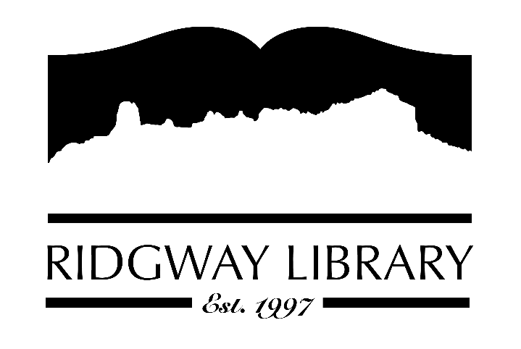

AGENDA
RIDGWAY PUBLIC LIBRARY DISTRICT
BOARD OF TRUSTEES
Regular Meeting
Thursday, December 12, 2024 at 10:30 a.m.

Ridgway Public Library
300 Charles Street

Zoom option:

https://us06web.zoom.us/j/85434900418?pwd=AG3lMFauLoV5DJ5oL5lhl54OuGdb5T.1

Passcode:
114219

Roll Call: Trustees: Julie Duff, Alison Etheridge, Jared Coburn, Julie Herrmann, Dee Moore, Heather Patterson, Sally Trapp, Library Director: Amy Baer

Approval of Prior Minutes: from November 14, 2024 meeting

Next Meeting: Discuss January meeting time

Public Comments:

Friends of the Library Update:

Highlighted Topic: Adult Bingo will begin Thursday January 2nd and run through Monday March 31st

Action and Discussion Items:
- Approve and sign operating budget for 2025 – all trustees
- Staff Workshop opportunity/discussion & approval – Amy
- Annual director evaluation review – all trustees

Treasurers Report - Julie Duff
- Budget update

Director’s Report - Amy Baer
- Statistics
- Community Outreach

Future Agenda Items

- Election of officers
- Strategic goal setting/board retreat

Adjournment
The Board reserves the right to add or delete items of business and to change the order of business as needed. The Board welcomes public participation in the meetings. If specific accommodations are needed, please contact the Director, Amy Baer, (970)626-5252 or email abaer@ridgwaycolibrary.org at least 24 hours in advance of the meeting.

