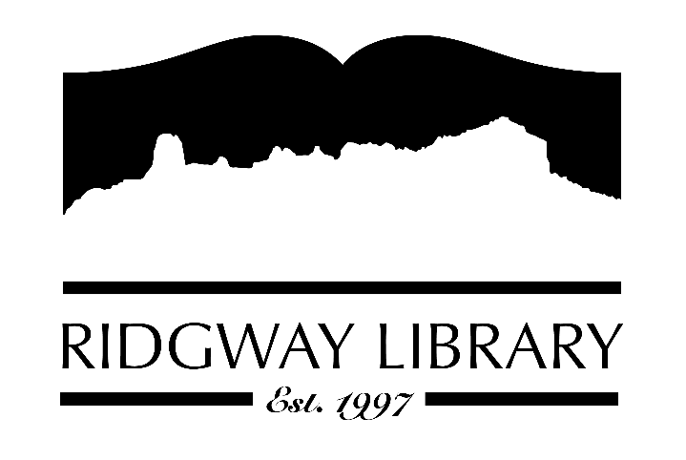

AGENDA
RIDGWAY PUBLIC LIBRARY DISTRICT
BOARD OF TRUSTEES
Regular Meeting
December 9 2022

Ridgway Public Library
300 Charles St.

Zoom option:
https://us06web.zoom.us/j/88564802262?pwd=ZUpjRFRqVFIyQWZMS0F3ZUlDb0kxUT09

Passcode:
939493

Roll Call: Trustees: Julie Duff, Sandy Hennessy, Dickson Pratt, Jeff Pryor, Sally Trapp, Jenny Williams, Library Director: Amy Baer

Approval of Prior Minutes:

Next Meeting: TBD

Public Comments:

Friends of the Library Update:

Action and Discussion Items:

- Interview & talk with board applicants for January 2023
- Approve signage for Young Adult and Children’s Area – Amy
- Board Training Update – Sandy
- Email accounts for board members – Sally
- Library Director Employment Agreement – Sally

Treasurers Report - Julie Duff
Present 2023 draft budget
**“Roll Call” vote for annual budget

Director’s Report - Amy Baer

Statistics
Puzzle and Game shelf
Inventory is 95% complete
FAMLIA meeting
Staff Workshops
Community Outreach

Adjournment

The Board reserves the right to add or delete items of business and to change the order of business as needed. The Board welcomes public participation in the meetings. If specific accommodations are needed, please contact the Director, Amy Baer, (970)626-5252 or email library@ouraynet.com at least 24 hours in advance of the meeting.

