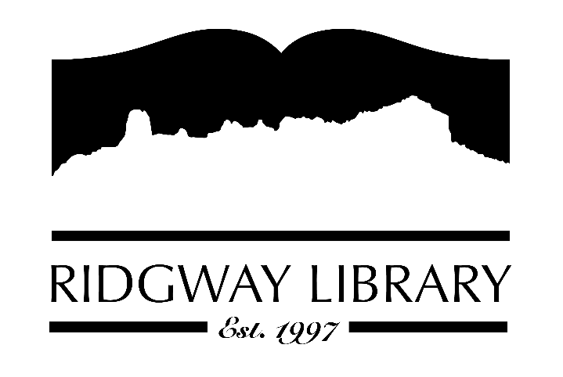

AGENDA
RIDGWAY PUBLIC LIBRARY DISTRICT
BOARD OF TRUSTEES
Regular Meeting
Friday March 10, 2023 at 1:00 p.m.

Ridgway Public Library
300 Charles Street

Zoom option:
https://us06web.zoom.us/j/87826551291?pwd=a2srU3pBR1lRSGhTNm8reWFwZnM5Zz09
Passcode:
942950

942950Roll Call: Trustees: Julie Duff, Alison Etheridge, Sandy Hennessy, Jeff Pryor, Sally Trapp, Jenny Williams, Library Director: Amy Baer

Approval of Prior Minutes:

Next Meeting: Friday April 14, 2023 at 1:00 PM

Public Comments:

Friends of the Library Update:

Action and Discussion Items:

- Presentation of Gratitude – All Board Members
-Discuss and possible action for Trustee Emeritus.
- Interview of Trustee Candidates - All Board Members
- 2023 Goals with Discussion – All Board Members
- Set date for Executive Session to review evaluation forms - Sally

Treasurers Report - Julie Duff

Director’s Report - Amy Baer
- Maintenance Update
- Seed Library & upcoming class
- Material ordering
- Community Outreach
- Summer Reading Update
- Audit Report
- PLAR Report
- CliC Workshop

Future Agenda Items

Adjournment

The Board reserves the right to add or delete items of business and to change the order of business as needed. The Board welcomes public participation in the meetings. If specific accommodations are needed, please contact the Director, Amy Baer, (970)626-5252 or email library@ouraynet.com at least 24 hours in advance of the meeting.

