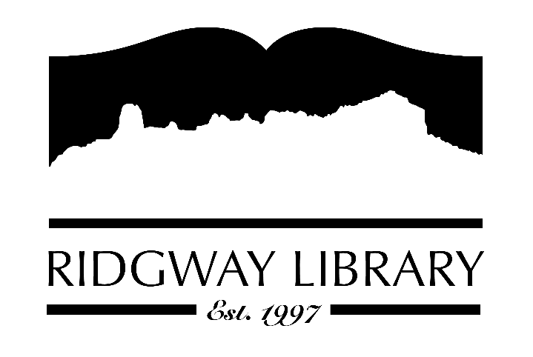

PUBLIC NOTICE
RIDGWAY PUBLIC LIBRARY
300 CHARLES ST
RIDGWAY, CO 81432

Zoom option:

https://us06web.zoom.us/j/82097001508?pwd=Eah3AUkbnEsd0VwTRJFZAkXCoFJ2sO.1

Passcode:
350550

Notice is hereby given that on Monday, March 3, 2025 at 10:30 a.m.

Ridgway Public Library Board of Trustees will hold a subcommittee meeting:

Library Trustees are holding a meeting to discuss CAL awards.

E-mail responses may be submitted to abaer@ridgwaycolibrary.org To reach Amy Baer, Director by phone call (970)626-5252.

Dated: February 25, 2025 ____________________________________
Amy Baer
Director

